

Target: ___/56 or ____ % 👍 👎

56

Year 8 HASS- Geography

***Task 1: In Class Short Answer Response (5% weighting)***

***(Introduction to Geography and Landforms and Landscapes)***

***Name: ____________________ Teacher: ________________***

**Time: 5 minutes reading time and 45 minutes working time.**

**Section One: Multiple Choice**

**Read each key term, or statement, and circle only one option from A-D with a pencil as your response.**

**(10 marks)**

1. The acronym we use to remember the key concepts of geography are:
   1. BOLTSS
   2. PQE
   3. SPICESS
   4. SHEEPT
   5. SPICES
2. The acronym we use to remember the key features of a map are:
   1. BOLTSS
   2. PQE
   3. SPICESS
   4. SHEEPT
   5. SPICES
3. Geography is the study of:
   1. the past, particularly people and events of the past
   2. the economy and how it relates to people
   3. people and places in the world
   4. politics and law
4. Geography can be divided into two main branches;
   1. Psychological Geography and Human Geography
   2. Physical Geography and Human Geography
   3. Human Geography
   4. Physical and Animal Geography
5. The following elements are NOT part of a landscape:
6. living elements
7. invisible elements
8. human elements
9. changeable elements
10. The Dreaming is associated with the:
11. Squamish peoples of Canada.
12. Indigenous peoples of Australia.
13. Sioux Plains Indians of America.
14. Apache tribe of America.
15. The aesthetic value of a landscape relates to:
16. its beauty.
17. its business and economic importance.
18. the emotional connections we have with it.
19. spiritual and sacred sites.
20. A landform is best defined as;
21. A human made feature on the earth’s surface.
22. A very light and porous volcanic rock.
23. A natural feature on the earth’s surface.
24. A natural feature on the ocean’s surface.
25. A landscape created by humans that features roads and buildings, and often results in the destruction of natural landscapes is known as a landscape.
26. Karst
27. Arid
28. Mountain
29. Riverine
30. Built
31. The lines on a topographic map that show points of equal height above or below sea level are known as:
    1. Contour lines
    2. Concave lines
    3. Convoluted lines

**Section Two: Short Answer**

**1.** **State what each letter in the acronym BOLTSS stands for:**  **(6 marks)**

B -

O -

L -

T -

S -

S -

**2. Matching Activity – Write the letter of the correct definition next to the number. (7 marks)**

1. ___________
2. ___________
3. ___________
4. ___________
5. ___________
6. ___________
7. ___________

|  |  |
| --- | --- |
| **Concept** | **Explanation** |
| **1**  SUSTAINABILITY | **A**  The size or level at which a geographical inquiry takes place – *personal, local, regional, national or global* |
| **2**  PLACE | **B**  The ongoing capacity of Earth to maintain all life. Using resources in a way that is managed so there is enough for future generations. |
| **3**  SCALE | **C**  The way things are arranged on the Earth’s surface within a specific area. |
| **4**  CHANGE | **D**  A specific part of the Earth’s surface that is identified and given meaning by people. |
| **5**  SPACE | **E**  A description of the surroundings and all the things within it, both living and non-living. |
| **6**  INTERCONNECTION | **F**  The relationship between all things, both living and non-living, and all processes, both natural and human. |
| **7**  ENVIRONMENT | **G**  The dynamic nature of all processes on Earth that alter conditions, whether slow or fast, small or large. |

**3. Select two of the key concepts from the table on the previous page and provide a geography-related example. (4 marks)**

**Key concept:**

**Example:**

**Key concept:**

**Example:**

1. **List four types of maps you have studied in geography. (4 marks)**



1. **List four types of landforms. (4 marks)**



1. **List four types of landscapes. (4 marks)**



1. **Explain the difference between a landform and a landscape. Provide examples to support your response. (Note: A good response will include ‘whereas’ or ‘however’) (5 marks)**

1. **Explain how one Australian landscape is valued. Consider the following values: aesthetic, emotional, spiritual or economic. (6 marks)**

Landscape:

Explain how the landscape is valued.

**Section Three: Data analysis (6 marks)**

Source 1:

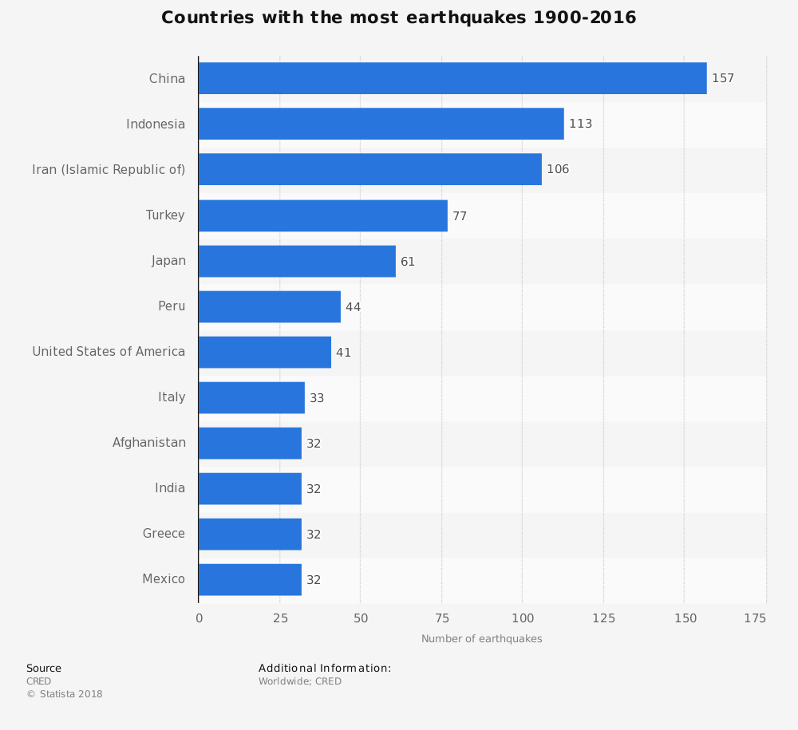

Study source 1. Refer to source 1 to address the following questions.

1. State which country has the most earthquakes.
2. State the number of earthquakes Peru has had from 1900 to 2016.
3. Explain what the data shows you. (Note: A good answer will refer to source 1) (4 marks)

**END OF TEST**